**Grad 2025 Meeting #7 – Thursday, May 8, 2025**

1. Grad Auction: We need to decide on a new date as Saturday May 10 the school has been booked for a gymnastics tournament. *Grads decided to have auction on May 24. All items are submitted to the office. Corrine will lock them up. To see if a business has been contacted look at the list on this link:* [Grad Auction](https://o365sd70-my.sharepoint.com/:l:/g/personal/shagar_sd70_bc_ca/FNJOsa8Jn5lLvgeb5vZpbfoBT86p5oNH4CPGwxyNcxvx8A?e=Vmgq86)
2. Grad Hoodies $50 each: We need to approve the designs and start taking orders. *Part of the design is missing. Ms. Cirella will contact the printer and have it corrected. Students are happy with the size and general design otherwise.*

Students will be reimbursed after grad auction (if they bring items). When should the ordering deadline be? Choose your colour!

Have a look at ATC website for colour options:

<https://www.sanmarcanada.com/atcf2500.html>

*Deadline for orders and payment for hoodies is next Thursday, May15.*

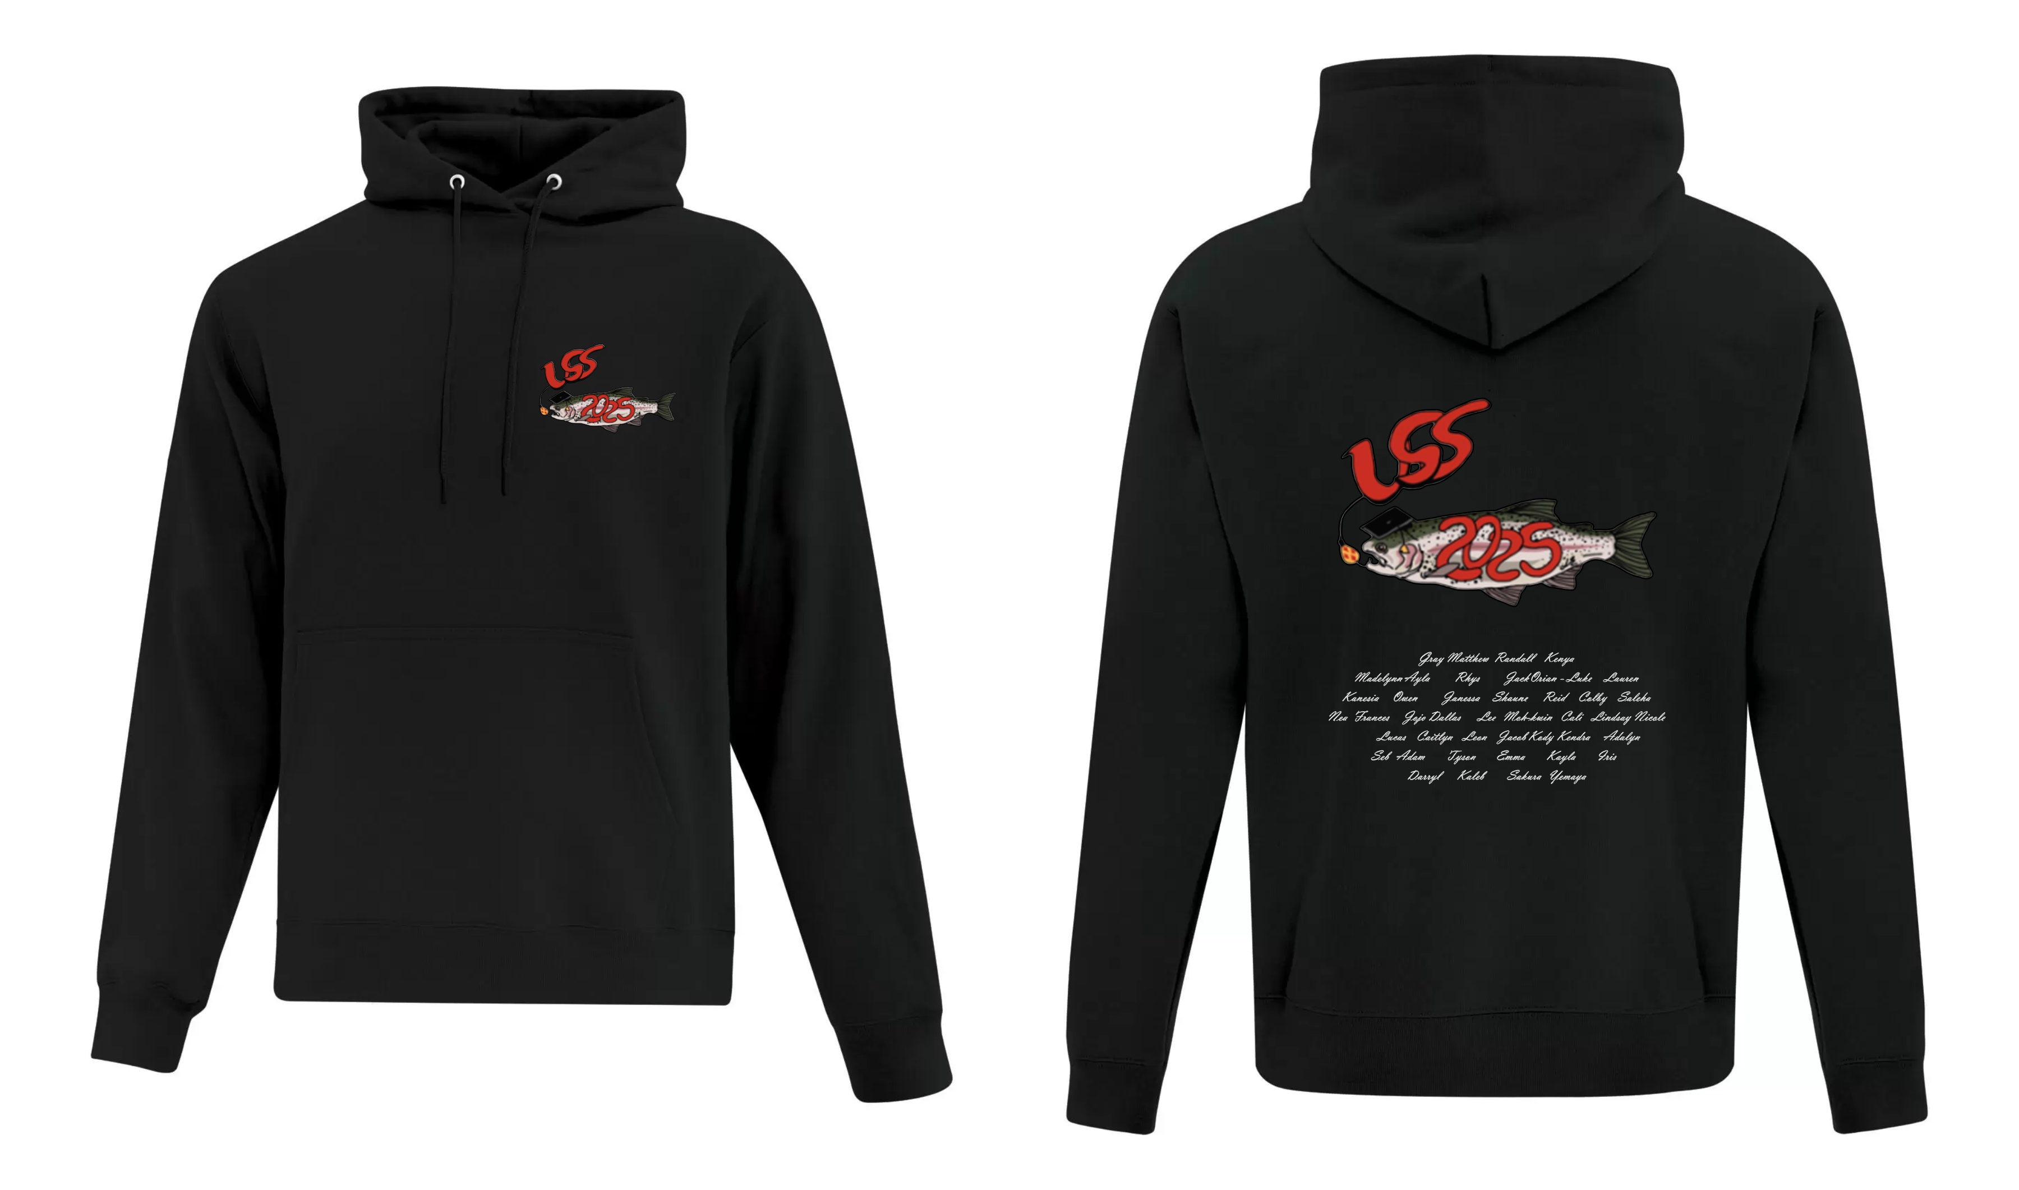

1. Pre Grad-Events ideas and date –

**Possible one day ideas**: Zipline, Wildplay, beach day, go-carting, mini golf, dinner at Montana’s, Escape rooms, Tubing

*Students voted and the most popular choices were: Wildplay and Mini Golf. Ms. Cirella has sent requests for available dates in June. We can decide on a date at next meeting.*

1. Grad Photographer – *Sarah has not found one yet. She’s still looking. Does anyone know of someone?*
2. Grad Display items – give to McWhinney by June 1
3. What is a conditional acceptance? *Keep showing up to class. Need help with next steps? See Sarah*

**NEXT MEETING is Thursday, May 15 at lunchtime?**

Email [shagar@sd70.bc.ca](mailto:shagar@sd70.bc.ca) or [ocirella@sd70.bc.ca](mailto:ocirella@sd70.bc.ca)

All Grad correspondence will be posted on the USS website under the Graduation tab.

Grad Hoodie Order Form

*Hand this form and your $50 into the office or Ms. Cirella by May 15/25*

|  |  |
| --- | --- |
| First Name |  |
| Last Name |  |
| Hoodie Size (S-4XL) |  |
| Colour |  |
| Paid ($50) |  |