Subject Who? |  |  |  | 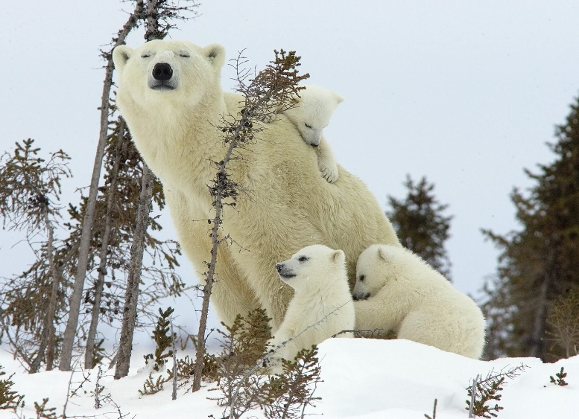
Common noun | Proper noun |  | Pronoun
Predicate What?
Action Verb
Subject  Who or What the sentence is about  (Always a noun person, animal, place, thing, idea) |  | Predicate  Verb (action) + object  did or does what action is done to what
The baby polar bear |  | snuggles into his mother’s fur.
__________________________________ |  | ________________________________________________________  ________________________________________________________
__________________________________ |  | ________________________________________________________  ________________________________________________________
__________________________________ |  | ________________________________________________________  ________________________________________________________
__________________________________ |  | ________________________________________________________  ________________________________________________________

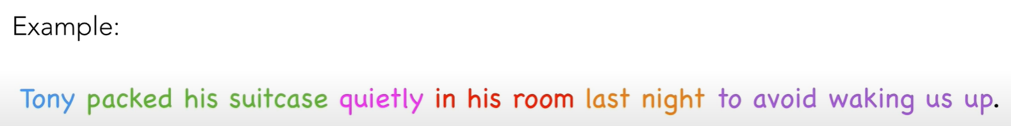
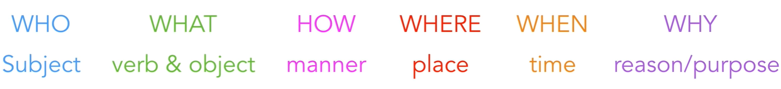

____________________________________________________________________________________________________________________________________________________________________________________________________________________________________________________________________________________________________________________________________________________________________________________________________________________________________________________________________________________________________________________________________________________________________________________________________________________________________________________________________________________________________________________________________________________________________________________________________________________________________________________________________________________________________________________________________________________________________________________________________________________________________________________________________________________________________________________________________________________________________________________________________________________________________________________________________________________________________________________________________________________________________________________________________________________________________________________________________________________________________________________________________________________________________________________________________________________________________
Subject |  | Predicate
Adjective | Who? | Did/Does what? | The action was/is done to what?
(Determiner or description) | noun | Verb  (action) | object
 | I | ate | a juicy apple.
 | Sheila | ran | to the goal post.
A | giraffe | reached high | with it’s neck.
The | teacher | wrote | examples
 | Ben | rode | his skateboard.
Those | basketball | need | air pumped into the.

