English Sentences
subject
who? or what?
the sentence is about
(The naming part)

predicate
The action
tells what the subject does or did. (The telling part)

+

Fred + jumped.
Dogs + bark.
+
complete predicate
The action + details
(When? Where?Why?How?)

Complete subject
who? or what?
the sentence is about
+ details (description of
the subject)

Silly Fred + jumped right over the chair.

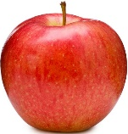
Happy dogs + bark when they want to play.

The apple + tastes delicious.

- A basic sentence is one complete thought.
- A subject and a predicate together make a complete thought or what is called an independent clause.

- Every written sentence must start with a capital letter and end with one of three punctuation marks;
- a period (.), - used most often. This symbol tells a reader the complete thought is finished.
- a question mark (?), - is used only when a writer is asking a question.
- or an exclamation mark (!) – a writer uses this symbol to give importance to a sound, a word, or a phrase. For example, Boom! Get out of the way!
The Subject

The subject of a sentence can be a person, an animal, a place, an object or thing, or an idea. In English grammar these words are called nouns.

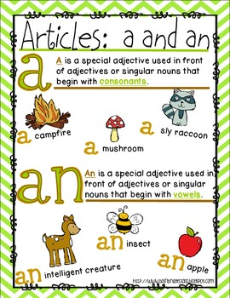
The subject of a sentence may need an article. There are two articles.

- The – used before a noun to be clear or specific about the noun.
For example, The dog on the street.
The teacher in the hall.
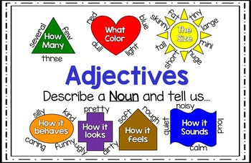
- A or an – used before a noun when you are being general. A is used before a noun that starts with a consonant and an is used before a noun that starts with a vowel.

An apple can fall from a tree.
A car can go fast.
Articles help describe the noun. You can use other words to describe the subject or noun in a sentence. We call these describing words adjectives.

When using more than one adjective to describe a subject or a noun, there is an order you need to follow in the descriptions you choose to use.
1 | determiner or article |  | A, an, the, those, her, their, our,  Adjective Order
2 | quantity or number |  | Four, several, many, one, few
3 | opinion |  | Beautiful, Expensive, Adorable, Delicious, Magnificent, Shiny, Sparkly, strange, caring, calm
4 | Physical Description | size | Huge, Tiny, Big, Gigantic, Small, Skinny, massive
5 |  | shape | Round, Square, Oblong, Flat, Chubby. Curved. hallow
6 |  | condition  (looks, feels, sound) | Broken. Rusted. Clean, Dirty, rough, ugly, Bright, clear, muddy, noisy, loud,
7 |  | age/time | Old, New, Ancient, modern, early, swift, rapid, slow
8 |  | colour | Red, Orange, gree, blue, purple, black, cream
9 |  | pattern | Striped, repetative, plaid, checkered, floral, polka dotted,
10 | origin |  | French, Italian, Thai, British, farmed, home-made
11 | material |  | Gold, silver, wooden, metal, cloth, natural
12 | purpose |  | Sleeping, touring, hunting, dining, Christmas, learning, viewing
Subject or noun

Adjective/Subject Examples
NOTE: When using 2 or more adjective you need to use a comma between each one accept for determiner or article.
- The many, beautiful, bright, red, orange, and yellow flowers
- Those large barrels
- Our expensive, old, red vase
- The big, modern, dining table
- A large, juicy apple
- An awesome, sleeping bag
The Predicate
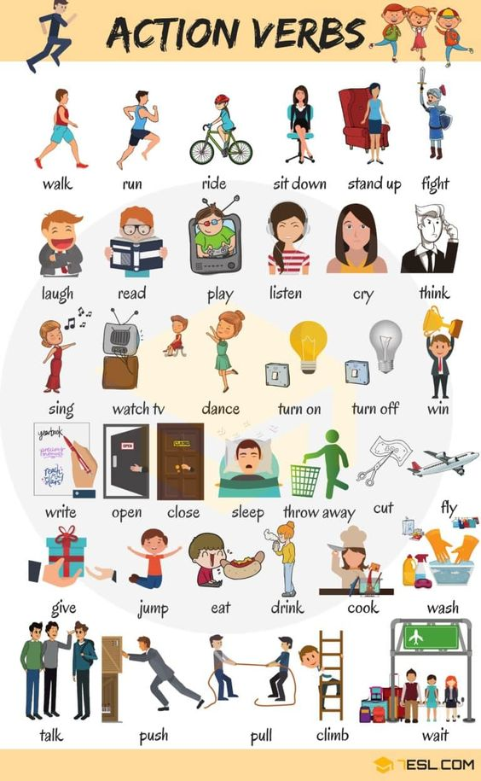
The predicate of a sentence is the
action the subject did or does. A
writer will use details like where the
action happened, or when the action
took place, or how the action was done
or why the action was done.
Action Verbs

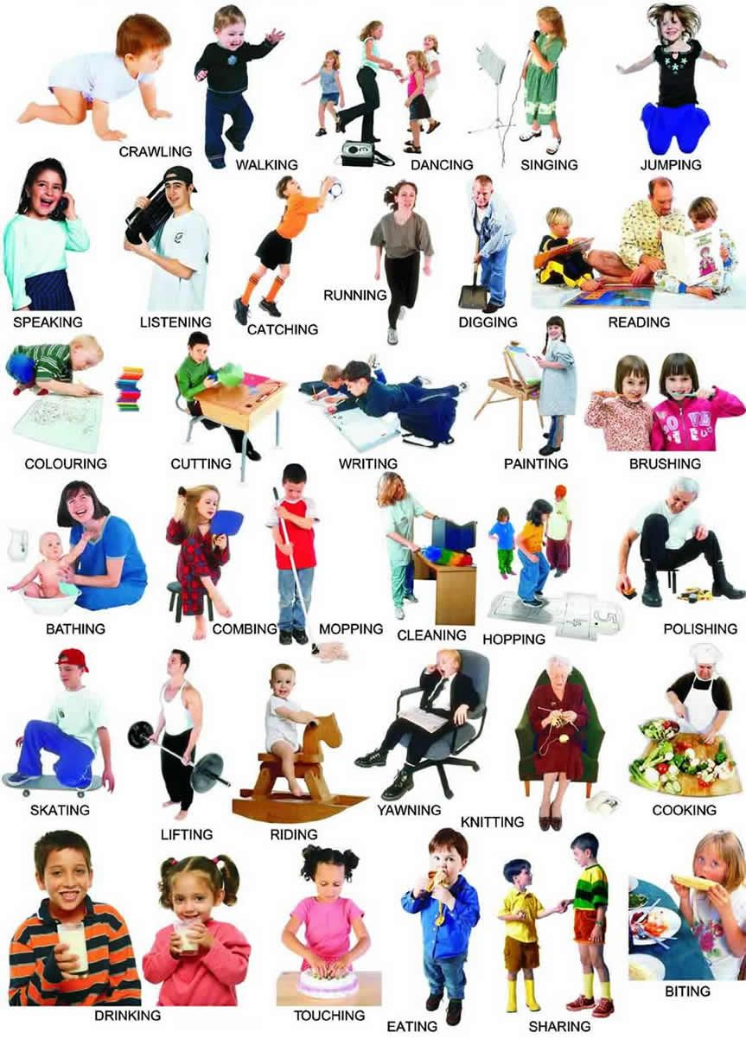

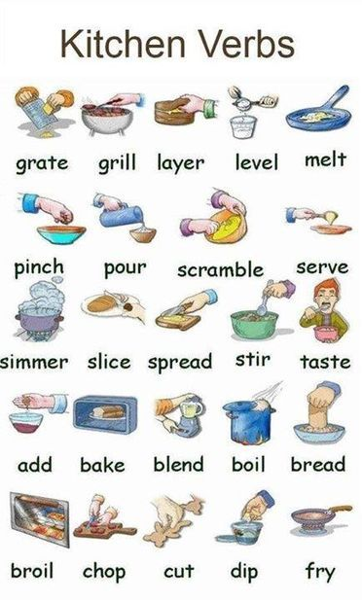

Adding Important Details
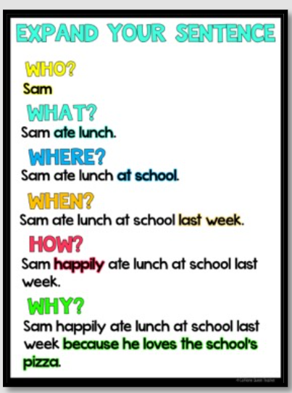
Subject
Predicate

Subject |  | Predicate
Adjective | Who? | Did/Does what? | The action was/is done to what? | Where? | When? | Why?
(Determiner or description) | noun | Verb  (action) | object | place | time | Reason/purpose
 | I | ate | a juicy apple |  | today | as my snack.
 | Sheila | ran |  | to my house |  | so we could start our project.
A | giraffe | reached high | with it’s neck |  |  | to get the juiciest leaves off the tree.
The | teacher | wrote examples |  | on the board.
 | Ben | rode | his skateboard |  | first | to show his new stunt.
Compound Sentences
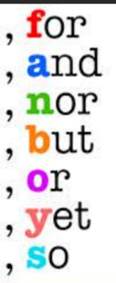
A compound sentence is when two basic sentences or two independent clauses are joined by a word called a conjunction. A comma is used just before the conjunction word.
A complete sentence
A complete sentence

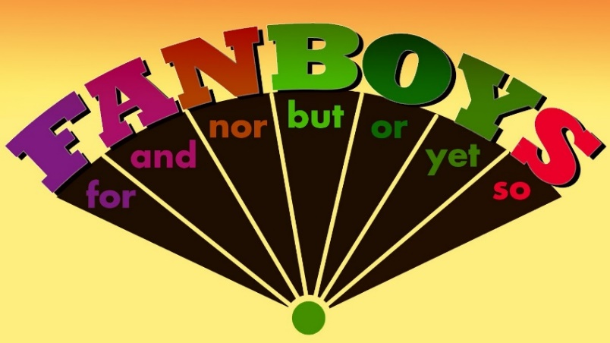
Tom walked to class, but Nolan ran.
I fell off the swing, so my friend made sure I was OK.

An easy way to remember the connecting words is F.A.N.B.O.Y.S
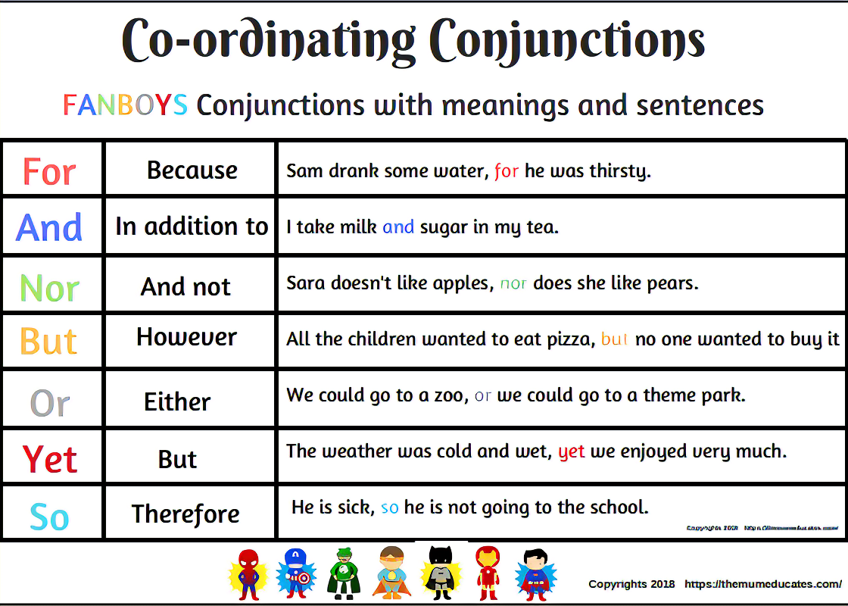

Complex Sentences
Is used to put across more detailed ideas. You have one main piece of information that can be a simple sentence on its own and one or more pieces of information that link to the main piece.
An independent clause or a complete thought.

The hungry owl hooted loudly then flew away as it spotted its next meal.
A dependent clause or an incomplete thought.
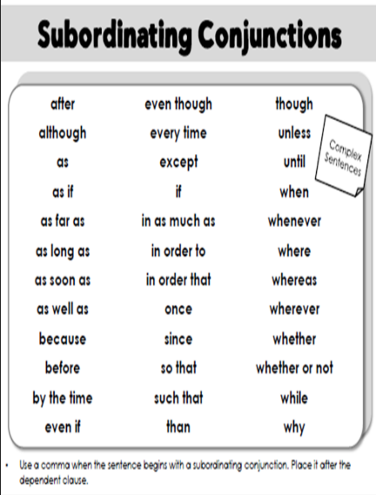
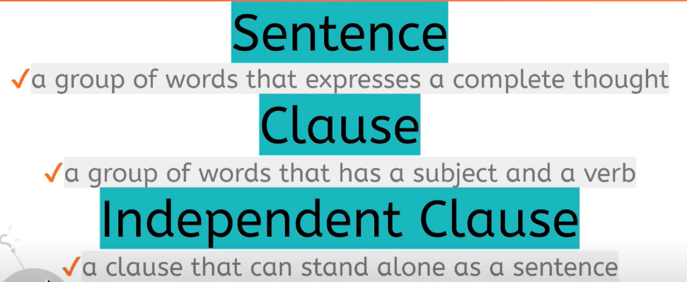

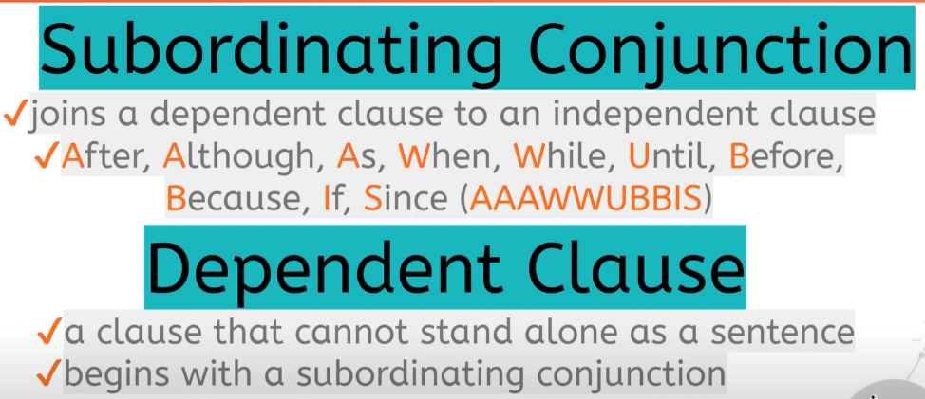

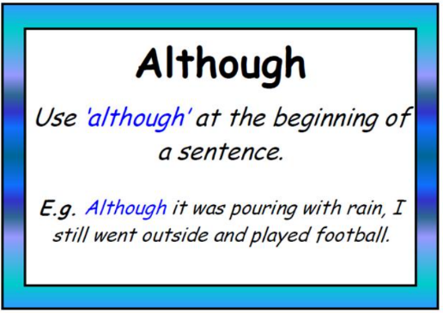

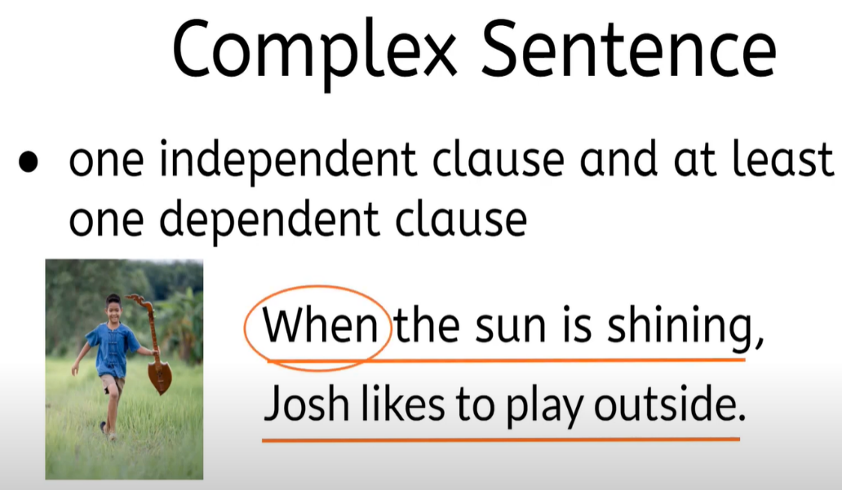

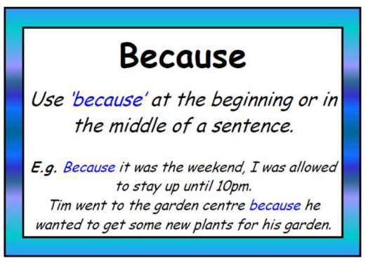

Sentence Frames

Basic sentences
person
animal
place
thing
idea

action
Clouds formed.
subject predicate
who did what
noun verb
Action done to what
___________ ___________ ____________.
Subject Verb Object
time
day
season
Predicate
place
_______, __________ __________ ____________ _________ .
When, Subject – WHO Verb (did what) Object (to what) where
Predicate

_______, _________ ________ ________ _______ ____________. .
When, adjective(s) subject verb object where
Predicate

_____, _______ _______ ______ _______ ________ _______ .
When, adjective(s) Subject Verb Object Adverb (how?) where
Predicate
Compound sentences

___________________, for ___________________. (because)
(Complete sentence) (complete sentence)

___________________, and ___________________. (in addition to)
___________________, nor ___________________. (and not)
___________________, but ___________________. (however)
___________________, or ____________________. (either)
___________________, yet ___________________. (but)
___________________, so ____________________. (therefore)

Complex Sentences
although
while
because
provided that
before
until
now that
since
as soon as

Part of a sentence
Complete sentence
____________ _____________ ____________
Independent sentence subordinating words dependent clause

____________ _____________ ____________
Independent sentence subordinating words dependent clause

