‘’

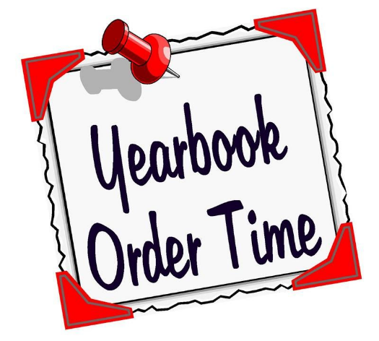
Alberni District Secondary School
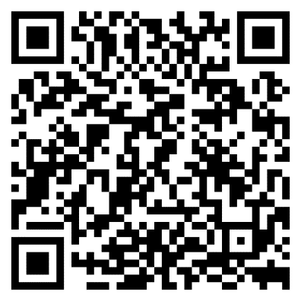
2024 Yearbook
$55 each

Purchase your copy online
with credit card or PayPal
http://ybstore.friesens.com/stores/300700

*Please use a separate form for each yearbook purchased:
Student Name:
Grade:
Phone #:
If not ordering online, please complete this form and bring your cheque (payable to ADSS) or cash $$ to Mr. Roberts – Room #250

Cash Cheque | Name on Cheque: |  | Home phone:
Date: |  | Email Address:

Capture your High School memories - order your copy today!

**All orders are final.
Refunds are not available**

Calling all photographic superstars!

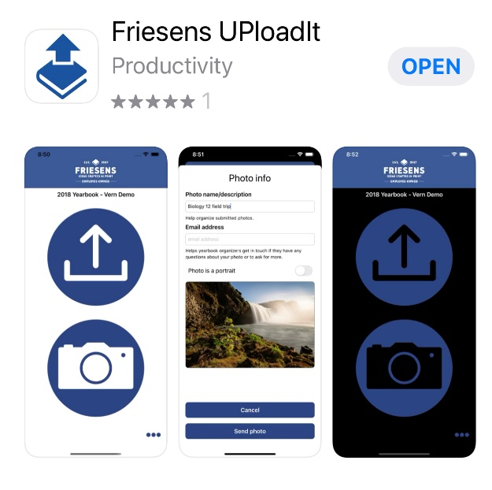
We need your help! Do you have an interesting photo to share of our school or community?

STUDENTS & ADSS COMMUNITY – the Friesen’s UPloadIt App is now live! You can now send photos straight from your phone to ConnectMe for the yearbook team to use in the 2024 ADSS Yearbook quickly and easily. All photos will be approved by the Yearbook Admin before being considered by the team.

Download the app today from your app store
the school project code for ADSS is 299149

**NOTE – IF YOU DOWNLOADED THIS APP LAST YEAR, YOU NEED TO
UPDATE IT WITH THE NEW PROJECT CODE FOR THE 2024 YEARBOOK**

