Wickaninnish Community School Primary School Supply List 2025-2026
(Grade 1-3)
1 x Crayola 24 Pk Crayons | 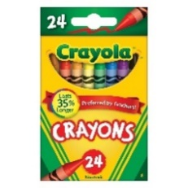 | 1 Pair Child Scissors | 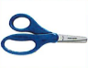
2 X Crayola Thick Markers | 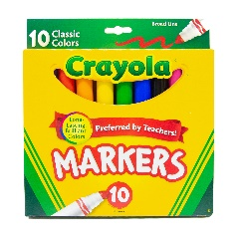 | 1 Box of Kleenex | 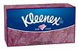
1 X Crayola Pencil Crayons | 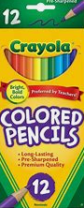 | 2 x Green Hilroy  ½ Blank ½ Lined | 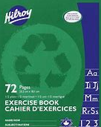
2 x White Erasers | 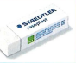 | 1 Hilroy Coil Scrap Book | 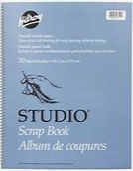
6 X Large Elmers Glue Sticks | 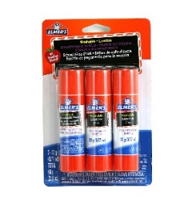 | 5 Duotangs Different colors pref. | 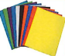
1 X 24 Pack HB Pencils | 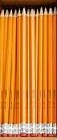 | 5 Large Ziplock Freezer bags | 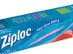
1 PK of individual whiteboard markers | 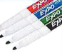 | 1 Labelled Water bottle | 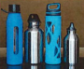
1 Pair of Gym Runners-No Laces | 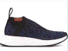
1 Pair of labelled Rain Boots | 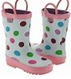
1 Pair of Labelled Rain Pants | 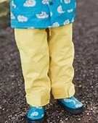
1 Set of Spare Clothes for Rainy Days | 