Kindergarten School Supply List

Shared supplies
In Kindergarten we share all of the following school supplies. Please do not label them as they will all be shared!
2 x Crayola crayons  (24 pack) | 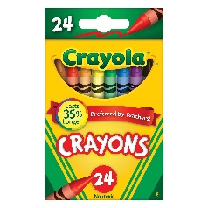
2 x Crayola thick markers (10 pack) | 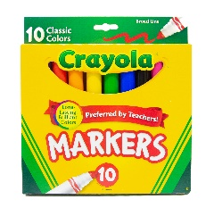
3 x Elmers glue sticks (1 pack) | 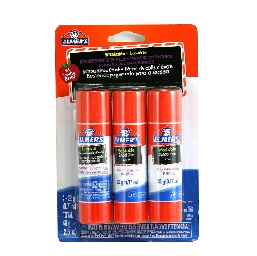
2 x Hilroy blank exercise books (blue, no lines) | 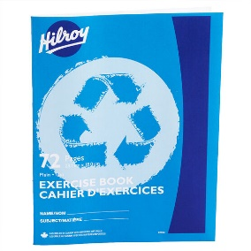
3 x white erasers | 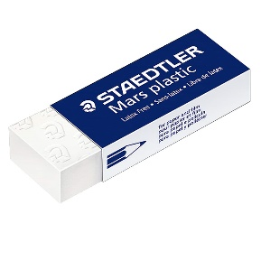
1 x Hilroy coil bound scrapbook (35.5x27.9cm)  **PLEASE purchase this exact one with a BLUE cover as it is a kindergarten keepsake book** | 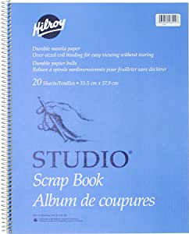
2 x plastic folders with pockets on each side | 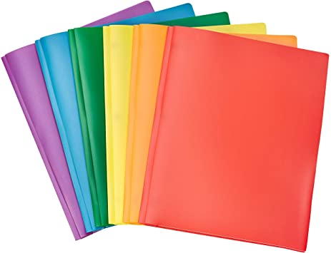
2 x Kleenex box | 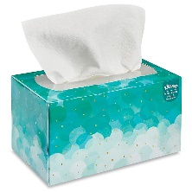
5 x large Ziploc bags | 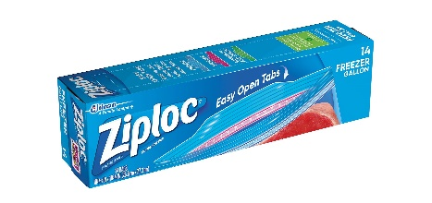
5 x fine tip Sharpies | 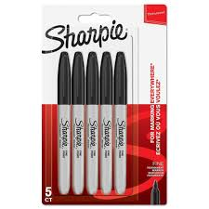  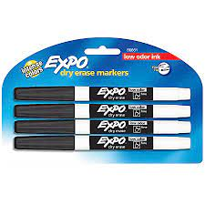
4 x thin black dry erase markers

Personal supplies
1 x labelled pair of clean, inside shoes (no laces, appropriate for the gym)
1 x full sized backpack
1 x labelled change of clothes (underwear, socks, pants, shirt, sweater)
1 x labelled water bottle
1 x labelled set of rain gear (boots, rain pants, jacket)

