Wickaninnish Community School Intermediate School Supply List
(Grade 4-7)
2 X Black Sharpies | 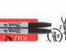 | 4 X White Eraser | 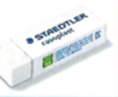
1 x Pencil Crayons | 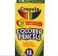 | 3 X Glue Stick | 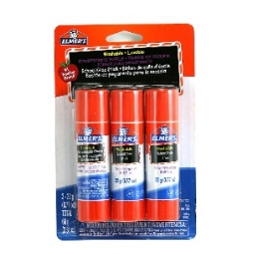
1 x Think Markers | 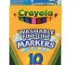 | 1 X Ruler | 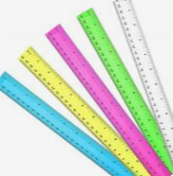
1 X Pencil Case | 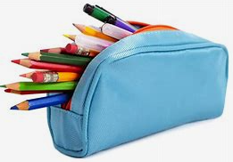 | 1 X Loose Leaf Paper | 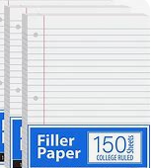
1 x Pencil Sharpener | 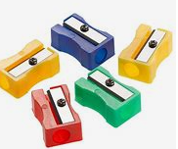 | Binder  (gr 6&7) | 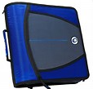
1 X HB Pencils | 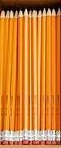 | Binder Dividers  (gr 6&7) | 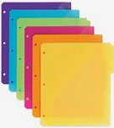
2 X Whiteboard Markers | 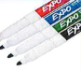 | Scissors | 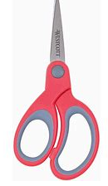
Agenda | 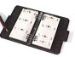 | Headphones | 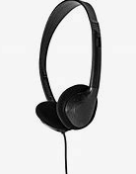
Runners |  | 1 X Kleenex | 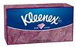
Rain Jacket, Pants, Boots | 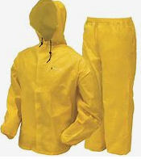 | Spare Clothes | 
Water Bottle | 

