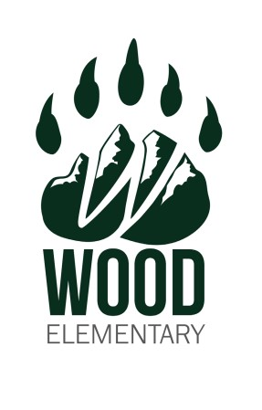Wood Elementary School Growth Plan

2025/2026

Principal – Darren Homan, Vice Principal – Julie Dawson

**Land Statement**

Wood Elementary School is situated on the ha-houlthees of the c̓išaaʔatḥ and hupačasath Nations and we acknowledge that we work alongside all Nuu- chah-nulth nations as well as the Métis Nation of British Columbia to serve the children and youth of the Alberni-Clayoquot region.

The school strives to increase awareness, understanding and integration of Nuu-chah-nulth culture, history and language. It is part of our ongoing commitment to Truth and Reconciliation.

## Our School Story

**What are the unique, positive characteristics that we celebrate in our school/community?**

Wood Elementary School is a vibrant and inclusive learning community where academic excellence, creativity, and strong community connections support the growth and development of every student. We are committed to providing a caring and supportive environment that nurtures the academic, physical, and social-emotional well-being of all learners within our diverse, multicultural setting.

Our dedicated and hardworking staff collaborate regularly to reflect on and improve teaching practices. In partnership with district literacy and numeracy resource teachers, we work to implement effective teaching strategies that support student success and well-being across all subject areas. This collaborative approach ensures that every student is given the tools and encouragement needed to thrive.

At a recent open house, parents and students overwhelmingly identified the warm, friendly, and inclusive nature of our staff as one of the most valued aspects of Wood Elementary. This welcoming atmosphere reflects our commitment to building strong relationships and a positive school culture where everyone feels a sense of belonging.

The Learning Commons is a central hub of student learning, functioning as a library, computer lab, and collaborative workspace. Our teacher-librarian works closely with classroom teachers to provide meaningful opportunities that include library and research skills, computer literacy, coding, and makerspace activities. In addition to supporting academic learning, the Learning Commons offers resources for social-emotional development, Indigenous education, SOGI inclusion, and anxiety support through EASE strategies.

At the heart of our school is The Den—our self-regulation room and a vital part of our daily routines. The Den is used to support students emotionally and academically by offering soft starts, re-set breaks, nutritional support, emotional regulation tools, and positive behaviour systems. It is a space where students can feel grounded, connected, and ready to learn.

We are also proud of our strong parent community. Our Parent Advisory Council (PAC) is a dedicated group of volunteers who organize fundraising initiatives and generously support school-wide learning opportunities, resources, and events that benefit all students.

At Wood Elementary School, we believe that learning thrives when supported by collaboration, compassion, and community. Through a shared commitment among staff, students, and families, we strive to create a meaningful and enriching educational experience for every child.

**What are the important demographics of our school and community?**

Wood Elementary School is a Kindergarten to grade 7 school with a current enrolment of 229 students. Our school is organized into 10 divisions, with most divisions including split grades. Of the 229 students 37 (16%) have ministry designations, and 90 (40%) have Indigenous ancestry.

Wood School staff consists of a Principal and Vice Principal, 11 classroom teachers, 8 Educational/Personal Assistants, part time counsellor, ISW worker, ELL teacher, part time speech and language pathologist, Indigenous Support Teacher, a full time Inclusion Support Teacher and a full-time secretary.

Wood School serves a diverse socio-economic community and is situated in central Alberni Valley. The location provides many amenities and opportunities for our students all within walking distance. (ice arena, swimming pool, public library, museum, ball fields as well as many wooded areas and trails).

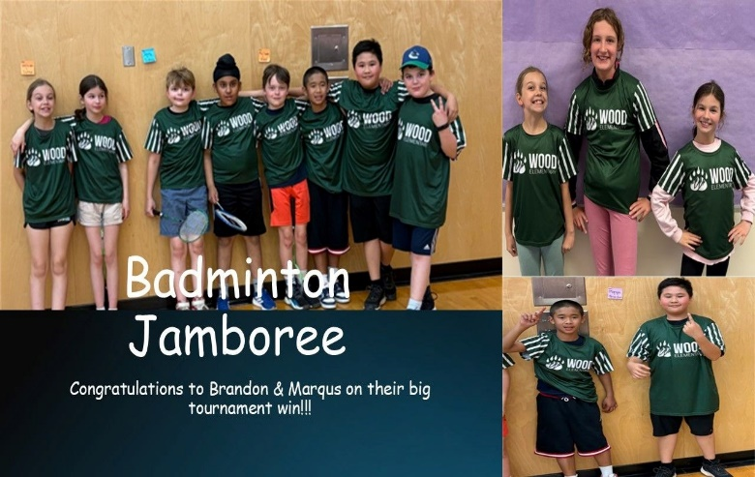

## Our School Goals

**Goal 1: In alignment with the SD 70 Strategic Plan for student achievement we aim to improve numeracy skills for all students.**

* Our objective is to increase percentage of students in proficient and extending grade level numeracy expectations for students K-7.

Key Strategies:

* Assess current numeracy data (District Assessments, Progress Reports and FSA) to examine achievement and set specific, realistic goals that are relevant to align with overall objectives of the District.
* Continual focused conversations with administrators and teaching staff regarding class numeracy plans.
* District Resource Teachers help guide instructional change practices by modelling in the classroom as well as at staff meetings and professional development days.
* Using school data, structure learning support team to target specific students in need of academic support. The support team (IST, Admin., ISW, LA and CEF Support) will meet once a month to discuss data, student learning progression, attendance, and allocate responsibilities in service provision.

**Goal 2: In alignment with the SD 70 Strategic Plan for student achievement we aim to improve literacy skills for all students.**

* Our objective is to increase percentage of students in proficient or extending grade level expectations in both reading and writing for students K-7.

Key Strategies:

* Focused conversations between administrators and teaching staff regarding class literacy plans. Encourage PLC’s or Inquiry projects to reflect learning trends and data results.
* District Resource Teachers present/share/model literacy initiatives in the classroom as well as at staff meetings and professional development days.
* Continue strategic early intervention reading program within primary grades.
* Increase parental involvement in literacy through work with the District Early Learning Team, information and education to parents about the benefits of reading with children, and access to free books.
* Using school data, structure learning support team to target specific students in need of academic support. The support team (IST, Admin., ISW, LA and CEF Support) will meet once a month to discuss data, student learning progression, attendance, and allocate responsibilities in service provision.

**Goal 3:** **In alignment with SD 70 Strategic Plan for Indigenous learner success and relationships with First Nations and Metis, we aim to ensure culturally relevant and welcoming environments for students and staff of Indigenous ancestry.**

➢ Our objective is to enhance Indigenous student engagement leading to improved student attendance and achievement in all curricular areas.

Key Strategies:

o Continue Monday morning group circle meeting to sing Na-shuk-ah-clin song. Include students in territorial acknowledgment

o Continue to use First Peoples Principles of Learning in every classroom.

o Coordinate Elders in residency program with ISW

o Look for opportunities to provide meals to families including a feast for National Indigenous Peoples’   
Day

## Data/Evidence

Although we are pleased with how many of our children are progressing both academically and socially our data also indicates areas for further improvement. For this document, we will highlight areas we will target improvement.

|  |
| --- |
| **Numeracy** |

**Progress Report Data:** The following table displays the percentage of our students proficient or extending as reflected in year-end progress reports.

|  |  |  |  |
| --- | --- | --- | --- |
| Year | 2023/24 | 2024/25 | 2025/26 |
| Whole School | 38% | 47% |  |
| Indigenous students | 33% | 41% |  |

**District Assessment Data:** The following table displays the percentage of our primary students proficient or extending on the Spring Early Numeracy Assessment.

|  |  |  |  |
| --- | --- | --- | --- |
| Year | 2023/24 | 2024/25 | 2025/26 |
| Grade 1 | 15% | 55% |  |
| Grade 2 | 39% | 19% |  |
| Grade 3 | 32% | 49% |  |

The following table displays our intermediate students proficient or extending on the Spring Island Numeracy Assessment:

|  |  |  |  |
| --- | --- | --- | --- |
| Year | 2023/24 | 2024/25 | 2025/26 |
| Grade 4 | 21% | 20% |  |
| Grade 5 | 22% | 28% |  |
| Grade 6 | 19% | 22% |  |
| Grade 7 | 25% | 27% |  |

**Foundation Skills Assessment Data:** The following table displays grade 4 and 7 students on track or extending on Numeracy Assessment.

|  |  |  |  |
| --- | --- | --- | --- |
| Year | 2023/24 | 2024/25 | 2025/26 |
| Gr. 4 Whole School | 28% | 72% |  |
| Gr. 4 Indigenous | 20% | 73% |  |
| Gr. 7 Whole School | 42% | 27% |  |
| Gr. 7 Indigenous | 45% | 33% |  |

|  |
| --- |
| **Literacy** |

**Progress Report Data:** The following table displays the percentage of our students proficient or extending as reflected in year-end progress reports.

|  |  |  |  |
| --- | --- | --- | --- |
| Year | 2023/24 | 2024/25 | 2025/26 |
| Whole School | 35% | 47% |  |
| Indigenous Students | 29% | 41% |  |

**District Assessment Data:** The following table displays our primary students proficient of extending on their Spring Reading Benchmark Assessment.

|  |  |  |  |
| --- | --- | --- | --- |
| Year | 2023/24 | 2024/25 | 2025/26 |
| Gr. 1 | 39% | 42% |  |
| Gr. 2 | 44% | 54% |  |
| Gr. 3 | 41% | 77% |  |

The following table displays our intermediate students proficient or extending on the Spring Reading 4- 7 Assessment.

|  |  |  |  |
| --- | --- | --- | --- |
| Year | 2023/24 | 2024/25 | 2025/26 |
|  | 23% | 27% |  |

The following table displays our intermediate students proficient or extending on the Spring District Wide Write Assessment.

|  |  |  |  |
| --- | --- | --- | --- |
| Year | 2023/24 | 2024/25 | 2025/26 |
|  | 35% | 29% |  |

**Foundation Skill Assessment Data:** The following table displays grade 4 and 7 students on track or extending on Literacy Assessment.

|  |  |  |  |
| --- | --- | --- | --- |
| Year | 2023/24 | 2024/25 | 2025/26 |
| Gr. 4 Whole School | 50% | 57% |  |
| Gr. 4 Indigenous | 33% | 55% |  |
| Gr. 7 Whole School | 45% | 49% |  |
| Gr. 7 Indigenous | 40% | 40% |  |

|  |
| --- |
| **Social Emotional Learning** |

**Middle Years Development Instrument (MDI):**

Grade 4 students responded there is an adult at my school that believes I will be a success.

|  |  |  |  |
| --- | --- | --- | --- |
| Year | 2023/24 | 2024/25 | 2025/26 |
|  | 76% | 60% |  |

Grade 4 students responded there are two or more important adults at school.

|  |  |  |  |
| --- | --- | --- | --- |
| Year | 2023/24 | 2024/25 | 2025/26 |
|  | 86% | 70% |  |

Grade 4 students responded when they are with other children their age, they feel they belong.

|  |  |  |  |
| --- | --- | --- | --- |
| Year | 2023/24 | 2024/25 | 2025/26 |
|  | 62% | 55% |  |

Grade 7 students responded there is an adult at my school that believes I will be a success.

|  |  |  |  |
| --- | --- | --- | --- |
| Year | 2023/24 | 2024/25 | 2025/26 |
|  | 50% | 57% |  |

Grade 7 students responded there are two or more important adults at school.

|  |  |  |  |
| --- | --- | --- | --- |
| Year | 2023/24 | 2024/25 | 2025/26 |
|  | 58% | 42% |  |

Grade 7 students responded when they are with other children their age, they feel they belong.

|  |  |  |  |
| --- | --- | --- | --- |
| Year | 2023/24 | 2024/25 | 2025/26 |
|  | 62% | 63% |  |

**Student Learning Survey**

**Grade 4:**

Grade 4 students feel welcome at school many times or all the time

|  |  |  |  |
| --- | --- | --- | --- |
| Year | 2023/24 | 2024/25 | 2025/26 |
|  | 80% | 63% |  |

**Grade 7**:

Grade 7 students feel welcome at school many times or all the time.

|  |  |  |  |
| --- | --- | --- | --- |
| Year | 2023/24 | 2024/25 | 2025/26 |
|  | 50% | 73% |  |

**Attendance:** 47% of our students missed more than 20 school days in 2024/25

## Our School Celebration Story

The Self-Regulation Room—affectionately known as The Den—continues to be a unique and vital space within Wood School. What began as a simple idea has grown into a central hub for both students and staff, offering a wide range of supports, resources, and tools that contribute to the overall well-being and success of our school community.

On any given day, The Den sees between 50 to 100 students pass through its doors. Students come for a variety of reasons: to reset and self-regulate during challenging emotional moments, to energize their minds and bodies in preparation for learning, or to access academic and nutritional support. Some visit to celebrate their achievements, engage in choice time, or simply because they need a moment of connection and encouragement.

The Den plays a key role in supporting students through the full range of emotions that arise during a busy school day—worry, frustration, anger, grief, joy, and excitement. It offers a calm, welcoming space where they can develop self-awareness and practice regulation strategies that will serve them well throughout their lives.

For staff, The Den is an essential resource center. Led consistently by Ms. Pley, our Inclusion Support Teacher, and supported by other specialists as needed, the space serves as the operational heart for student supports. Our systems for designated students—including bin/folder organization, technology access, adapted materials, and visual aids—are all coordinated from The Den.

We are incredibly proud of what The Den has become: a safe, inclusive, and dynamic space that empowers students and staff alike. It is a place where everyone is supported in being their best selves and where the foundational skills for lifelong learning and emotional resilience are nurtured every day.

In addition, this past year, we are proud to share learning results for our Indigenous students showed improvement across key academic areas, including reading, writing and numeracy. These gains reflect the collective efforts of staff, students, families and Indigenous partners in creating a more supportive and inclusive learning environment.

To continue this positive momentum, we have dedicated a .4 FTE (Full Time Equivalent) position specifically focused on supporting Indigenous learners. This role works closely with classroom teachers to provide both direct student support and guidance on how to integrate culturally responsive teaching strategies into daily instruction.

